Parts
- Ardunio Mega
- Dual G2 High-Power Motor Driver 24v14 Shield
- Power supply box
- Breadboard / circuit board
- 10 K resistor
- 12 Wires
- Bucket
- Fountain Pump 150
- 2 water tubes
- Rectangular module with center hole Peltier (max volts 6.1)
- Thermistor
- Water block
- Sapphire window

Hardware setup

Arduino Mega diagram:

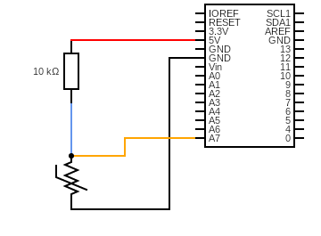

- Dual G2 High-Power Motor Driver 24v14 Shield diagram

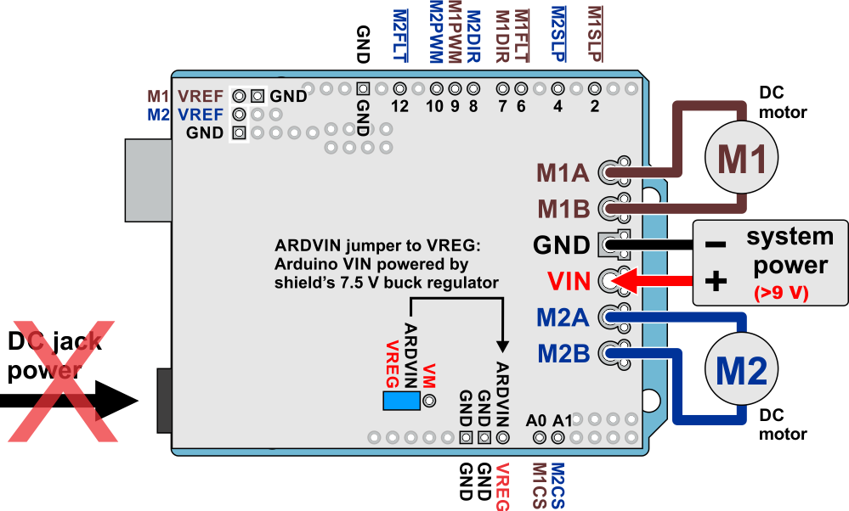
Solder the shield pins to the shield then place it on top of the arduino.

M1A/M1B are used for the motor ( arduino shield ) (*kind of arduino shield)
M2A/M2B can be used for another arduino setup or another motor

GND/VIN connects to the power supply

Use the Library Manager to install this shield library:

- In the Arduino IDE, open the "Sketch" menu, select "Include Library", then "Manage Libraries...".
- Search for "DualG2HighPowerMotorShield".
- Click the DualG2HighPowerMotorShield entry in the list.
- Click "Install".

Attaching the thermistor to the Peltier
- Use a good amount of thermal paste to the peltier and attach the Sapphire widow, make sure you push down hard to create a thin layer of thermal paste
- Clean up thermal paste around window with isopropyl alcohol
- Add super glue if needed
- Make sure widow doesn’t slide
- Attach thermistor near the sapphire window with super glue, also use copper tape to assist with the hold.

Attaching the waterblock to the Peltier

- Apply thermal paste to waterblock and attach the peltier to it and apply pressure.

Waterblock
Use any bucket with the Fountain Pump 150

Software setup

Tools / board / “ Arduino Mega”
Tools / processor / “ Arduino Mega”
Tools / port / “ Arduino Mega”

Code:

#include "DualG2HighPowerMotorShield.h"

//Thermometer with thermistor

/*thermistor parameters:

* RT0: 10 000 Ω

* B: 3977 K +- 0.75%

* T0: 25 C

* +- 5%

*/

//These values are in the datasheet

#define RT0 10000 // Ω

#define B 3977 // K

//-----------------------------------------------------------

#define VCC 5 //Supply voltage

#define R 10000 //R=10KΩ

//Variables

float RT, VR, ln, TX, T0, VRT;

double Setpoint;//

unsigned long time; //

int x = 40 ; // can change this number to whatever// basically the second setpoint
int x2 = 45; // 3rd setpoint
int x3= 50; // 4th setpoint etc // can add as many increments or decrements as needed

DualG2HighPowerMotorShield24v14 md;

void stopIfFault() //failsafe function to disable the M1 Output if there is a "fault"

{

if (md.getM1Fault())

{

md.disableDrivers();

delay(1);

Serial.println("M1 fault");

while (1);

}

}

void setup()

{

Serial.begin(115200);

Serial.println("Dual G2 High Power Motor Shield");

md.init();

md.calibrateCurrentOffsets();

delay(10);

Serial.begin(9600);

T0 = 25 + 273.15; //Temperature T0 from datasheet, conversion from Celsius to kelvin
}

// -------------------------------------------------------------------------------------------

void loop()

{

//Thermistor reading and printout

VRT = analogRead(A7); //Acquisition analog value of VRT

VRT = (5.00 / 1023.00) * VRT; //Conversion to voltage

VR = VCC - VRT;

RT = VRT / (VR / R); //Resistance of RT

ln = log(RT / RT0);

TX = (1 / ((ln / B) + (1 / T0))); //Temperature from thermistor

TX = TX - 273.15; //Conversion to Celsius

//---------------------------------------------------------------------------------------------------------------------------

//PID equation with thermistor as input

/*working variables*/

unsigned long lastTime;

double Input, Output;

double errSum, lastErr;

double kp=45, ki=0, kd=0;

/*How long since we last calculated*/

unsigned long now = millis();

double timeChange = (double)(now - lastTime);

/*Compute all the working error variables*/

Input = TX; //using the thermistor temp in deg Celsius as the PID input

Setpoint = 35; // original setpoint// The goal temperature of the PID in deg Celsius

if ( TX < 70 ) // leave this number at 70 unless your setpoint is above 70 then increase it accordingly
{
Setpoint = Setpoint + 0.63
; // add the offset value of the setpoint
}

//setpoint offset value
//25 0.13
//26 0.17
//27 0.2
//28 0.31
//29 0.32
//30 0.32
//31 0.41
//32 0.48
//33 0.45
//34 0.6
//35 0.63
//36 0.66
//37 0.77
//38 0.86
//39 0.84
//40 0.91
//41 0.95
//42 0.98
//43 1
//44 1.1
//45 1.08
//46 1.14
//47 1.19
//48 1.22
//49 1.23
//50 1.34
//51 1.43
//52 1.5
//53 1.55
//54 1.72
//55 1.72

// 1 min = 60000

// 5 mins = 300000

// 10 mins = 600000

// 30 mins = 1800000

// 1 hr = 3600000

// 2 hr = 7200000

if ( now > 1800000) // if time is Greater then ____ mins //
//if sepoint>x
{ Setpoint = Setpoint + (x-Setpoint); // when condition is true, setpoint is added to the x value to become the new setpoint //
// When you want to do decrement use this equation, Setpoint = Setpoint + (Setpoint-x);
}

if ( now >3600000) //

{ Setpoint = Setpoint + (x2-Setpoint); // second increment/ decrement

}

if ( now >5400000) // *updated // third increment/ decrement

{ Setpoint = Setpoint + (x3-Setpoint);
}

double error = Setpoint - Input;

errSum += (error * timeChange); //integral-type calculation of error vs. time

double dErr = (error - lastErr) / timeChange; //derivative-type calculation of change in error since last calculation

/*Compute PID Output*/

Output = kp * error + ki * errSum + kd * dErr; //THE PID EQUATION

/*Remember some variables for next time*/

lastErr = error;

lastTime = now;

//----------------------------------------------------------------------------------------------------------

//Print the peltier Output value (unknown units), and the thermistor temp (deg Celcius)

Serial.print("Output:"); //Print the PID response

Serial.print(Output);

Serial.print("\t");

Serial.print("Temperature:"); //print the temperature

Serial.print("\t");

//Serial.print("F ");

//Serial.print((TX * 1.8) + 32); //Conversion to Fahrenheit

//Serial.print("\t\t");

//Serial.print("K ");

//Serial.print(TX + 273.15); //Conversion to Kelvin

Serial.print("\t\t");

//Serial.print("C ");

Serial.println(TX);

delay(250);
//--------------------------------------------------------------------------------------------------

md.enableDrivers();

delay(1); // The drivers require a maximum of 1ms to elapse when brought out of sleep mode.

if ( TX > 75) // If temp goes above the set value then the program stops running

{
md.disableDrivers();
delay(1);
}

if ( Output > 0) //

{
{md.setM1Speed(Output);
stopIfFault();
}
{

Serial.print("M1 current: ");
Serial.println(md.getM1CurrentMilliamps());
}
delay(2);
}

if (Output <= 0)
{
//md.disableDrivers();
md.setM1Speed(Output);
stopIfFault();; // Put the MOSFET drivers into sleep mode.
delay(200);
}
}

Troubleshooting

I get an uploading error “ selected port avrdude”?
Make sure the Arduino is plugged into the computer
Make sure under Tools / port that you see “ Arduino Mega”
Check to see if all the wires are connected the right way via the schematic

I see the green light on the arduino that signifies that the arduino is on but my computer doesn’t recognize it in the port ?

Make sure that all the wires are soldered properly.

I have the pid programmed to increase in temperature but instead it decreases in temperature?
Switch the black and red wire on the arduino shield ( M1A/M1B )

